**Project Name:** Tip Calculator

**Technology Used:** JavaScript

**Project Specifications:**

**Functional Requirement**

* This application provide option for the User to Specify
  + Bill Amount
  + Tip Percentage
  + No. Of People
* Based on Above inputs it Shows
  + Tip Per Person
  + Total Per Per Person

**Non Functional Requirement**

* Uses OOPS Concept of wrapping up of data members and member function into a single unit.
* Code Contains Proper Comments for Methods/Properties
* Uses Exception Handling to check if the user enters only number as input in Bill.
* No Unused Code Segment
* Uses JavaScript Coding Conventions

**Tools and Workspace :** Visual Studio Code

**Test Cases**

**Test Case 1:**

Given that the restaurant bill is $100.00

The number of persons is 1

The person decides to give a tip of 5%

**Expected Output**: Tip Per Person=$5.00

Total Per Person =$105.00

**Actual Output**: Tip Per Person=$5.00

Total Per Person =$105.00

**Result:** PASSED

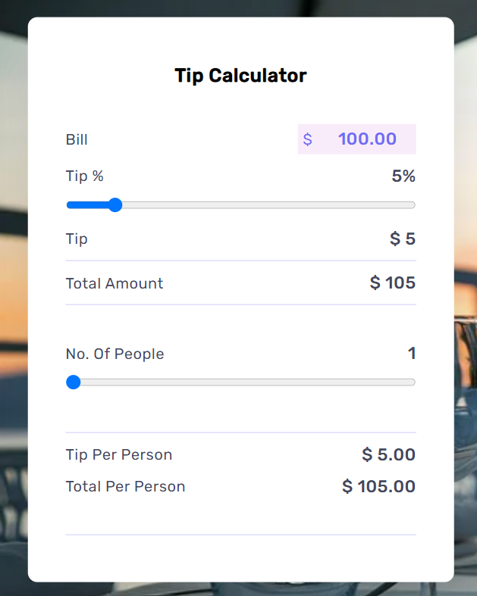

**Test Case 2:**

Given that the restaurant bill is $500.00

The number of persons is 2

They decide to give a tip of 10%

**Expected Output**: Tip Per Person=$25.00

Total Per Person =$275.00

**Actual Output**: Tip Per Person=$25.00

Total Per Person =$275.00

**Result:** PASSED

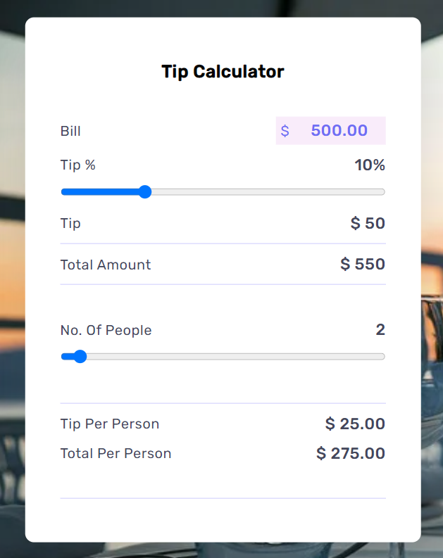

**Test Case 3:**

Given that the restaurant bill is $645.00

The number of persons is 3

They decide to give a tip of 10%

**Expected Output**: Tip Per Person=$21.50

Total Per Person =$236.50

**Actual Output**: Tip Per Person=$21.50

Total Per Person =$236.50

**Result:** PASSED

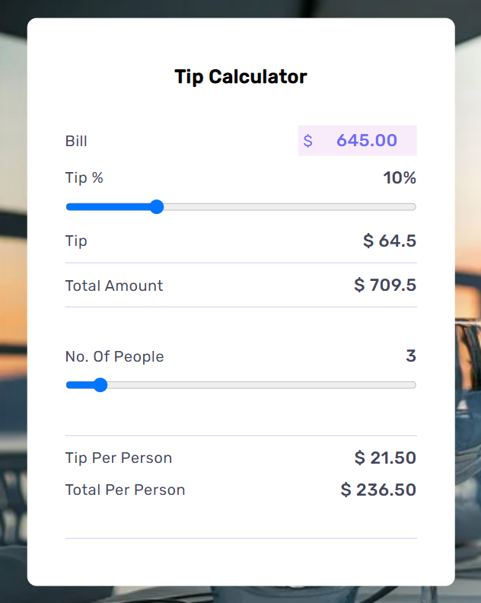

**Test Case 4:**

Given that the restaurant bill is $327.00

The number of persons is 2

They decide to give a tip of 5%

**Expected Output**: Tip Per Person=$8.18

Total Per Person =$171.68

**Actual Output**: Tip Per Person=$8.18

Total Per Person =$171.68

**Result:** PASSED

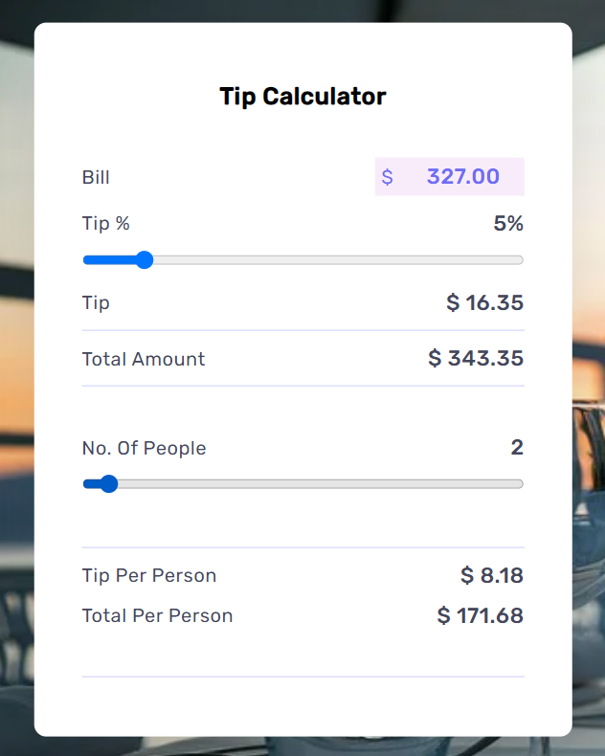

**Test Case 5:**

Given that the restaurant bill is $1241.03

The number of persons is 5

They decide to give a tip of 10%

**Expected Output**: Tip Per Person=$24.82

Total Per Person =$273.03

**Actual Output**: Tip Per Person=$24.82

Total Per Person =$273.03

**Result:** PASSED

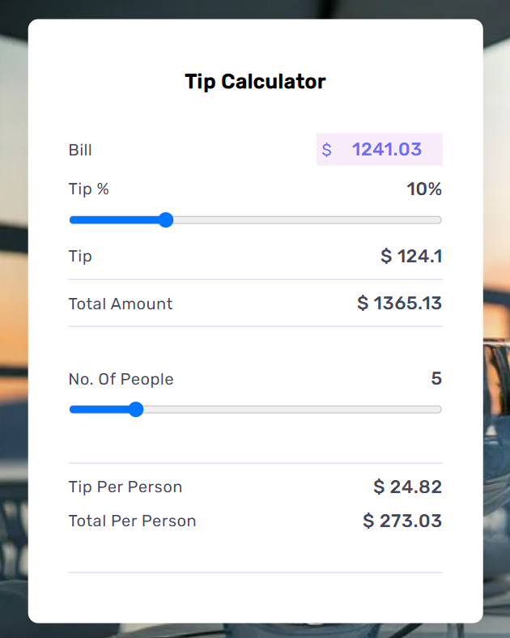

**Test Case 6:**

Given that the restaurant bill is $943.00

The number of persons is 3

They decide to give a tip of 8%

**Expected Output**: Tip Per Person=$25.15

Total Per Person =$339.48

**Actual Output**: Tip Per Person=$25.15

Total Per Person =$339.48

**Result:** PASSED

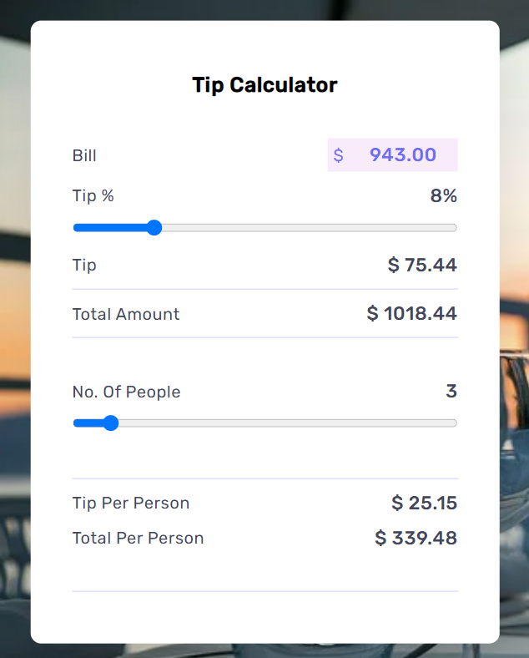

**Test Case 7:**

Given that the restaurant bill is $1030.00

The number of persons is 10

They decide to give a tip of 12%

**Expected Output**: Tip Per Person=$13.36

Total Per Person =$115.36

**Actual Output**: Tip Per Person=$13.36

Total Per Person =$115.36

**Result:** PASSED

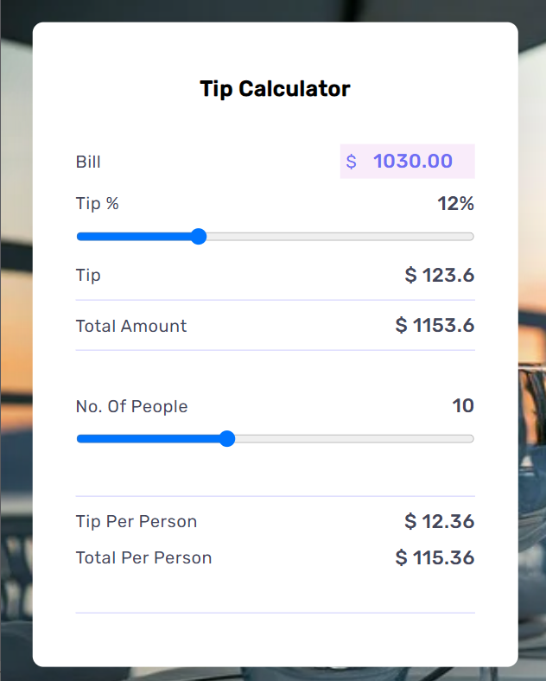

**Test Case 8:**

Given that the restaurant bill is $1041.75

The number of persons is 2

They decide to give a tip of 15%

**Expected Output**: Tip Per Person=$78.13

Total Per Person =$599.00

**Actual Output**: Tip Per Person=$78.13

Total Per Person =$599.00

**Result:** PASSED

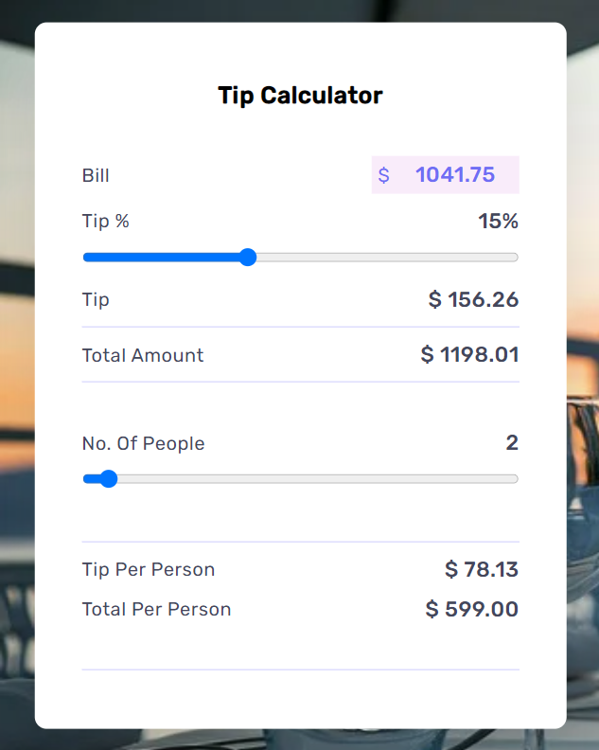

**Test Case 9:**

Given that the restaurant bill is $260.00

The number of persons is 1

The person decide to give a tip of 0%

**Expected Output**: Tip Per Person=$0.00

Total Per Person =$260.00

**Actual Output**: Tip Per Person=$0.00

Total Per Person =$260.00

**Result:** PASSED

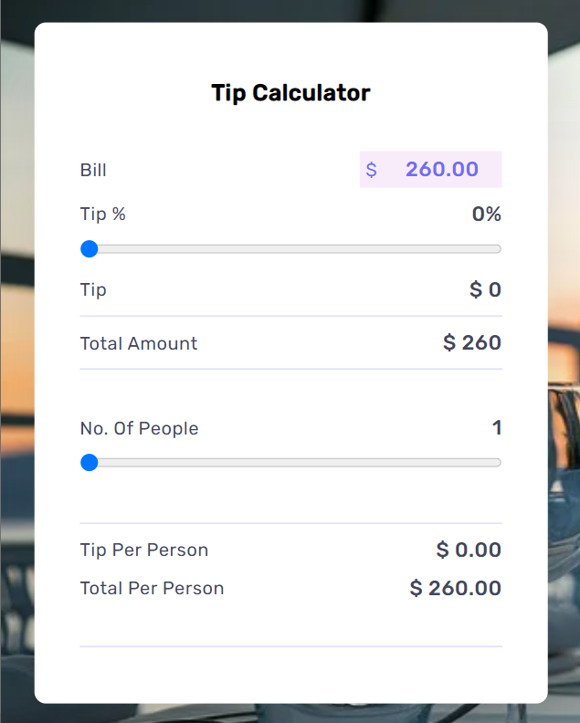

**Test Case 10:**

Given that the restaurant bill is $960.00

The number of persons is 3

They decide to give a tip of 32%

**Expected Output**: Tip Per Person=$102.40

Total Per Person =$422.40

**Actual Output**: Tip Per Person=$102.40

Total Per Person =$422.40

**Result:** PASSED

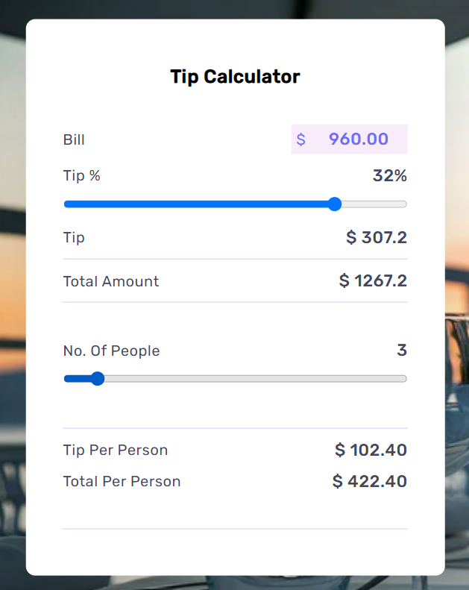

**Test Case 11:**

Given that the restaurant bill is $5600.00

The number of persons is 2

They decide to give a tip of 40%

**Expected Output**: Tip Per Person=$89.60

Total Per Person =$313.60

**Actual Output**: Tip Per Person=$89.60

Total Per Person =$313.630

**Result:** PASSED

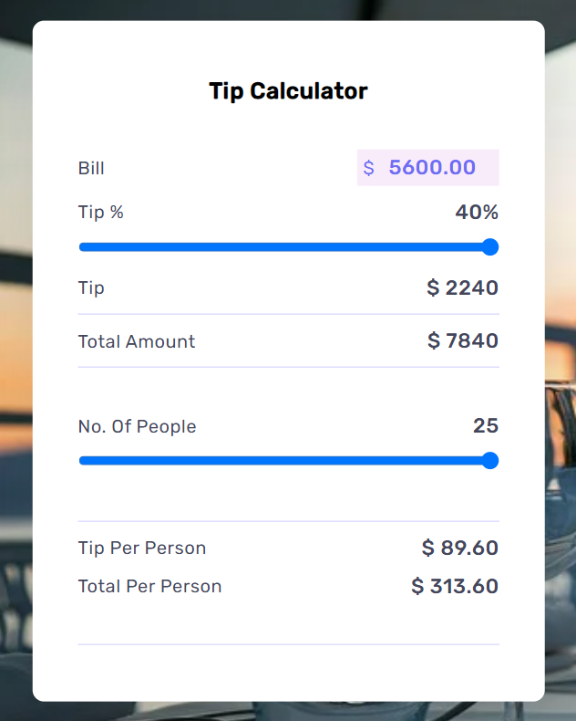

**Test Case 12:**

Given that the restaurant bill is $70.00

The number of persons is 1

The person to give a tip of 20%

**Expected Output**: Tip Per Person=$14.00

Total Per Person =$84.00

**Actual Output**: Tip Per Person=$14.00

Total Per Person =$84.00

**Result:** PASSED

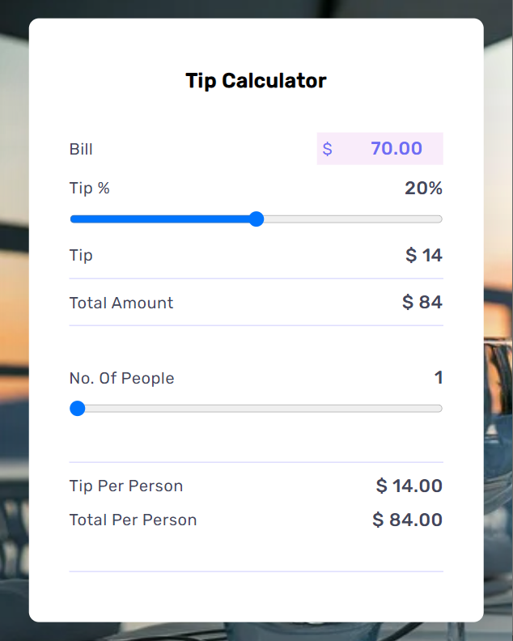

**Test Case 13:**

Given that the restaurant bill is $90.91

The number of persons is 1

The person to give a tip of 10%

**Expected Output**: Tip Per Person=$9.09

Total Per Person =$100

**Actual Output**: Tip Per Person=$9.09

Total Per Person =$100

**Result:** PASSED

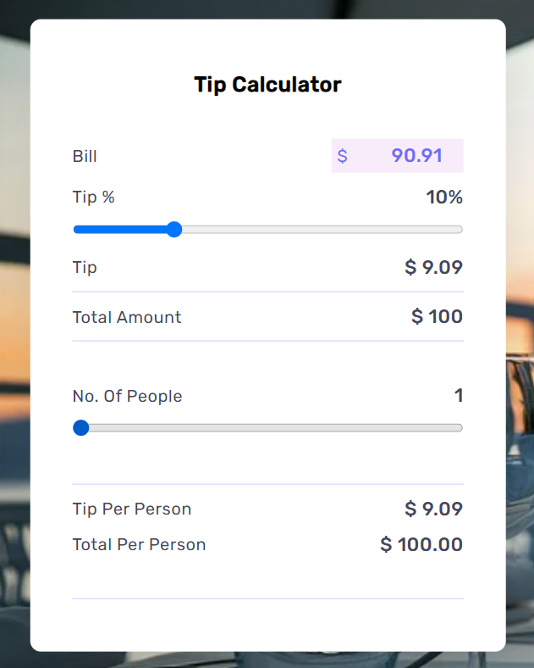

**Test Case 14:**

Given that the restaurant bill is $745.80

The number of persons is 3

They decide to give a tip of 30%

**Expected Output**: Tip Per Person=$74.58

Total Per Person =$323.18

**Actual Output**: Tip Per Person=$74.58

Total Per Person =$323.18

**Result:** PASSED

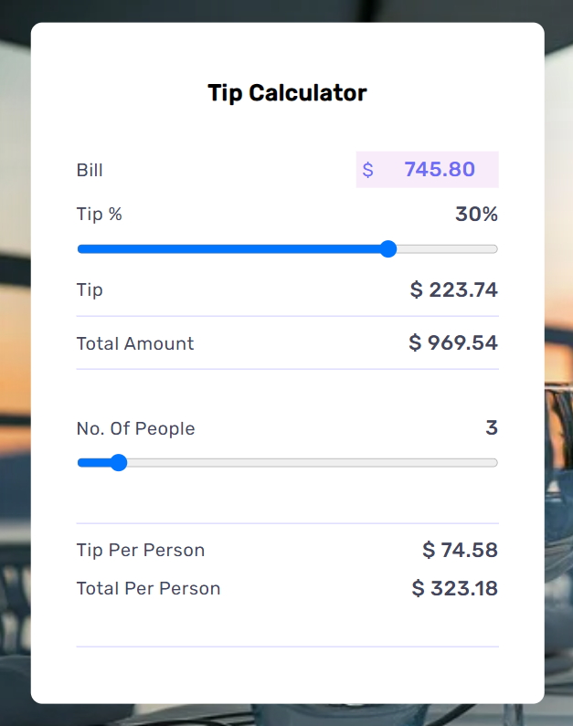

**Test Case 15:**

Given that the restaurant bill is $9876.54

The number of persons is 15

They decide to give a tip of 25%

**Expected Output**: Tip Per Person=$164.61

Total Per Person =$823.05

**Actual Output**: Tip Per Person=$164.61

Total Per Person =$823.05

**Result:** PASSED

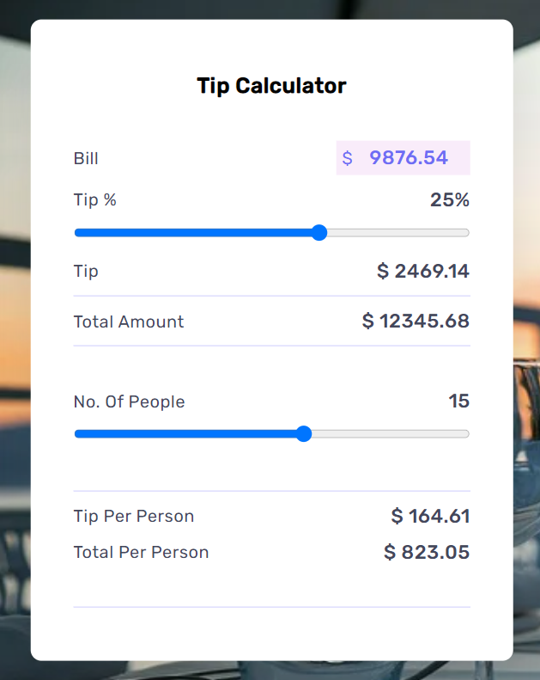

**Test Case 16:**

Given that the restaurant bill is $12345.67

The number of persons is 25

They decide to give a tip of 10%

**Expected Output**: Tip Per Person=$49.38

Total Per Person =$543.21

**Actual Output**: Tip Per Person=$49.38

Total Per Person =$543.21

**Result:** PASSED

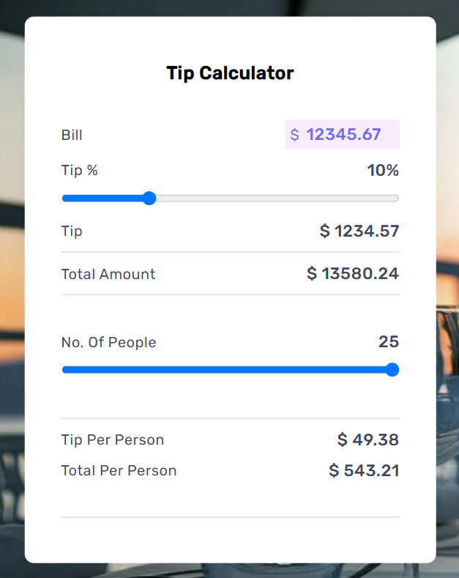

**Test Case 17:**

Given that the restaurant bill is $452.04

The number of persons is 5

They decide to give a tip of 40%

**Expected Output**: Tip Per Person=$36.16

Total Per Person =$126.57

**Actual Output**: Tip Per Person=$36.16

Total Per Person =$126.57

**Result:** PASSED

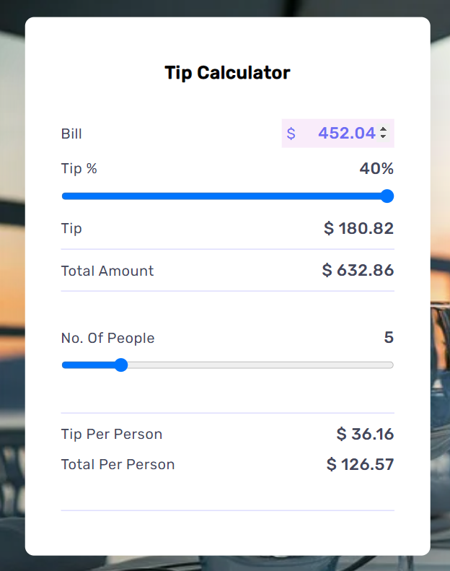

**Test Case 18:**

Given that the restaurant bill is $1302.57

The number of persons is 7

They decide to give a tip of 20%

**Expected Output**: Tip Per Person=$37.22

Total Per Person =$223.30

**Actual Output**: Tip Per Person=$37.22

Total Per Person =$223.30

**Result:** PASSED

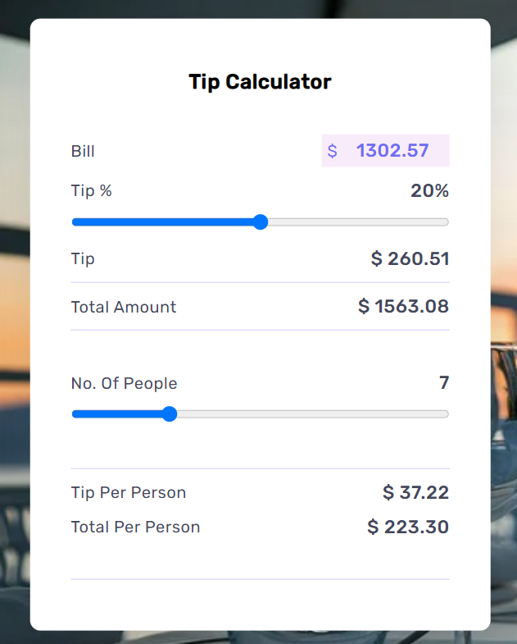

**Test Case 19:**

Given that the restaurant bill is $6789.01

The number of persons is 10

They decide to give a tip of 10%

**Expected Output**: Tip Per Person=$67.89

Total Per Person =$746.79

**Actual Output**: Tip Per Person=$67.89

Total Per Person =$746.79

**Result:** PASSED

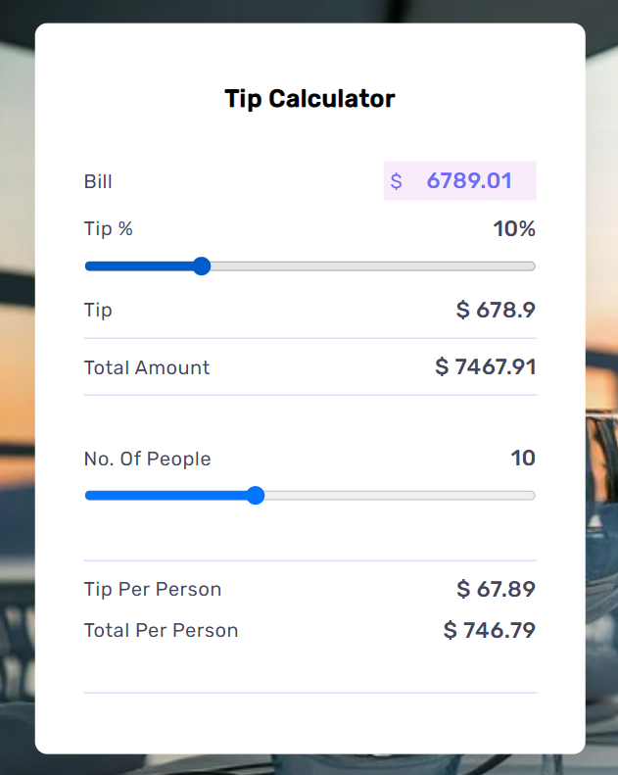

**Test Case 20:**

Given that the restaurant bill is $2000.00

The number of persons is 3

They decide to give a tip of 20%

**Expected Output**: Tip Per Person=$133.33

Total Per Person =$800.00

**Actual Output**: Tip Per Person=$133.33

Total Per Person =$800.00

**Result:** PASSED

